**Lab Exercise 4- Signed Commits in Git and GitHub**

**Objective:**  
To configure Git to sign commits with GPG, push them to GitHub, and verify commit authenticity for secure code contribution.

**Prerequisites:**

* Git installed on your system
* GPG (GNU Privacy Guard) installed and configured
* GitHub account with a repository (you own or have write access to)
* Basic knowledge of Git commands

**Step 1 – Generate or Use an Existing GPG Key**

1. **Check for existing keys**



1. **If no key exists, generate a new one**
   * Select **RSA and RSA**
   * Key size: **4096**
   * Expiration: **0** (never) or a fixed date
   * Enter your **GitHub-registered name and email**

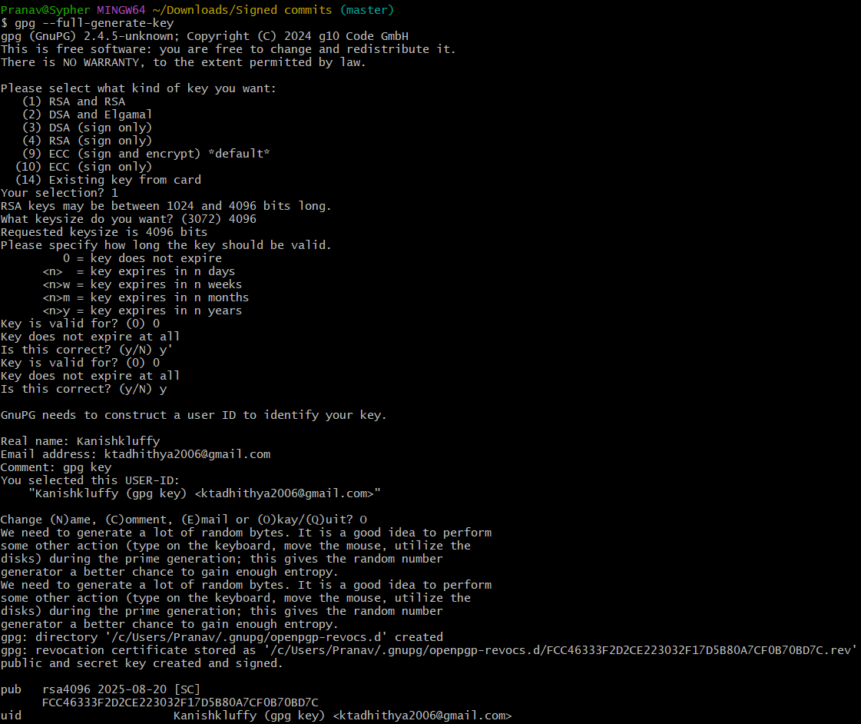

1. **Get your key ID**

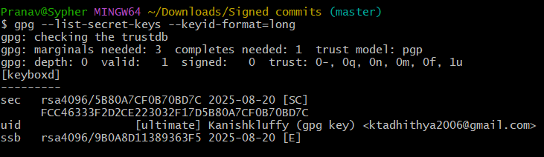

**Step 2 – Add GPG Key to GitHub**

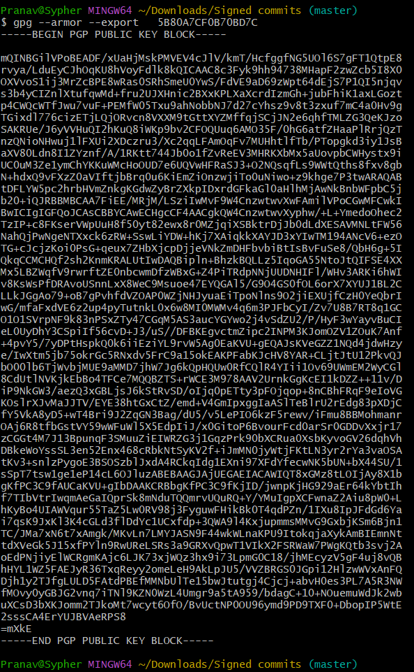

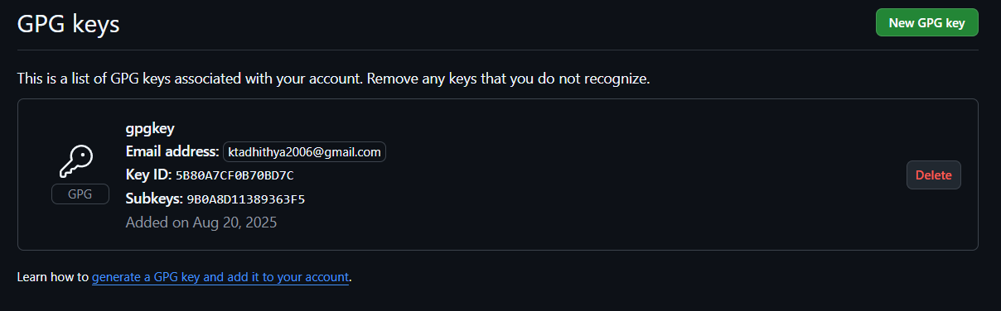

**Step 3 – Configure Git for Signed Commits**

1. Tell Git which key to use:

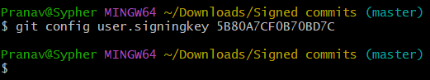

1. Enable signing for all commits:

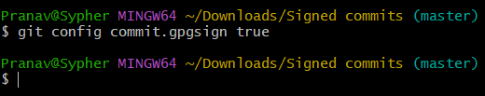

**Step 4 – Make a Signed Commit**

1. Clone your repo (or use an existing one):

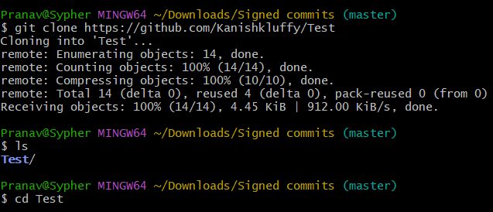

1. Edit or create a file:

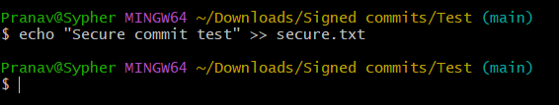

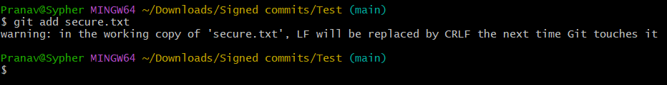

1. Commit with signing:

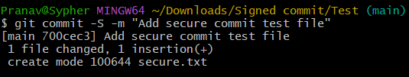

1. Enter your GPG passphrase when prompted.

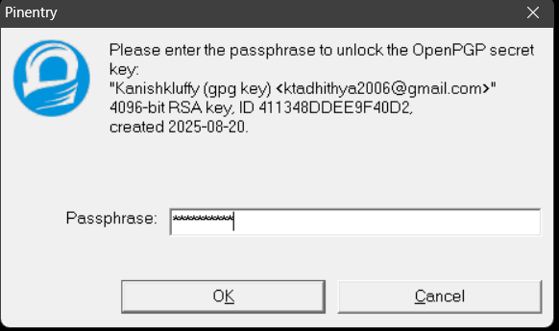

**Step 5 – Push and Verify on GitHub**

1. Push the commit:

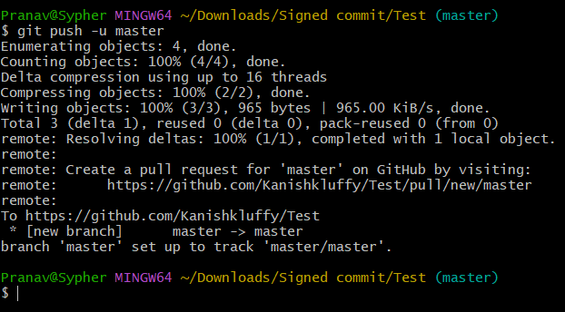

1. Go to your repository on GitHub → Click the commit → You should see a **green “Verified” badge**.

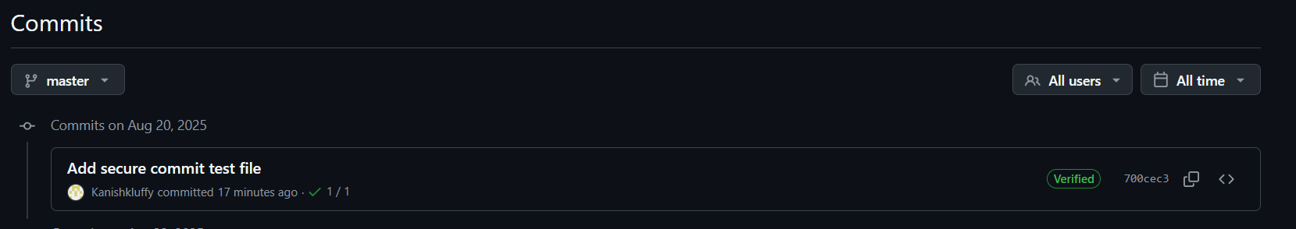

**Step 6 – Local Verification of Commit**

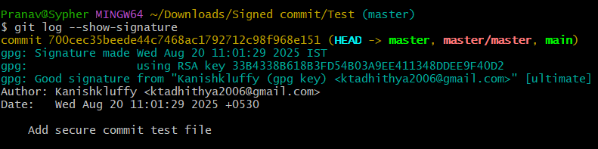

This will display the GPG verification details locally.

**Use Case**

Signed commits prevent identity spoofing in collaborative projects, ensuring only verified authors can make trusted changes in critical codebases.